**Bank Management System**

*Submitted by-* *Under the Guidance of*

Prithviraj Jagtap Monica Jadhav

Himanshu Londhe

Suyash Raskar

Utkarsh Thorat

**Abstract**

The Bank Management System project is a web application designed to provide an intuitive and user-friendly interface for essential banking operations. The system allows users to navigate seamlessly through features such as viewing account details, managing transactions, and accessing key banking services. Built with modern web technologies, the project focuses on delivering a visually appealing and responsive design to enhance the user experience. This platform showcases the potential for creating effective digital solutions for banking needs and sets the foundation for future enhancements to deliver a comprehensive and interactive banking system.

**Table of Contents**

* Introduction
* Objective
* Technologies used
* Implementation
* Output
* Conclusion

**Introduction**

The Bank Management System project is a web-based application designed to simplify and enhance the way users interact with banking services. In the modern era, where digitalization has transformed various sectors, the banking industry has also evolved significantly to offer seamless online services. This project aims to contribute to this transformation by providing a user-friendly platform that makes banking operations more accessible and efficient.

The project focuses on creating a visually appealing and interactive interface, allowing users to perform essential banking tasks such as viewing account details, transaction history, and accessing other relevant information. By prioritizing a smooth and intuitive user experience, the platform ensures that users can navigate and interact with its features effortlessly.

React.js was chosen as the development framework for this project due to its component-based architecture, reusable code, and ability to handle dynamic content efficiently. These capabilities enable the application to deliver high performance, scalability, and responsiveness, which are essential for creating an effective banking interface.

The design of the system is centered around simplicity, functionality, and accessibility. By leveraging modern design principles, the application ensures that users from various backgrounds can use the platform with ease. The responsive layout further enhances accessibility, allowing the application to perform optimally across different devices, including desktops, tablets, and mobile phones.

Although this project is limited to the front-end development of the Bank Management System, it provides a solid foundation for integrating additional features such as backend connectivity, database integration, and advanced security protocols in the future. This scalability ensures that the system can evolve to meet the growing demands of users and the banking sector.

In conclusion, the Bank Management System project demonstrates how technology can be utilized to improve user interactions and streamline banking processes. It serves as a stepping stone toward creating a comprehensive digital banking solution that aligns with the industry's technological advancements and user expectations.

**Objective**

The primary objective of the **Bank Management System** project is to create a user-friendly and visually appealing platform that simplifies banking operations for users. The project aims to deliver an intuitive interface where users can easily access essential features such as viewing account details and transaction history. By leveraging React.js, the system focuses on building a dynamic and efficient application that ensures flexibility, scalability, and smooth user interactions. A significant goal is to design a responsive layout that adapts seamlessly to various devices, ensuring accessibility for users on desktops, tablets, and mobile phones.

The project also emphasizes the importance of adhering to modern UI/UX principles to provide a professional and visually attractive design, enhancing the overall user experience. Performance optimization is another critical objective, ensuring that the application delivers fast and reliable functionality without any lags. Additionally, this project aims to establish a solid foundation for future scalability, enabling the integration of backend systems, advanced security features, and additional functionalities in subsequent phases.

**Technologies used**

1. **HTML (HyperText Markup Language):**  
   HTML is used as the backbone of the project to structure the content of the website. It defines the elements such as headings, paragraphs, forms, and buttons, providing a semantic foundation for the web application.
2. **CSS (Cascading Style Sheets):**  
   CSS is employed to style the website, enhancing its visual appeal and ensuring a consistent design. It is used to define colors, fonts, layouts, and animations, contributing to a professional and user-friendly interface.
3. **JavaScript:**  
   JavaScript is the scripting language used to add interactivity and dynamic behaviour to the website. It enables functionalities such as form validation, interactive components, and seamless transitions, making the website more engaging and functional.
4. **React.js:**  
   React.js is the core framework for building the web application. Its component-based architecture allows for reusable code and efficient rendering of dynamic content. React.js ensures that the website is scalable, fast, and easy to maintain.
5. **Bootstrap:**  
   Bootstrap is utilized as a CSS framework to accelerate the design process and ensure a responsive layout. It provides pre-designed components like navigation bars, buttons, and grids, which help in creating a polished and mobile-friendly interface with minimal effort.

**System Architecture**

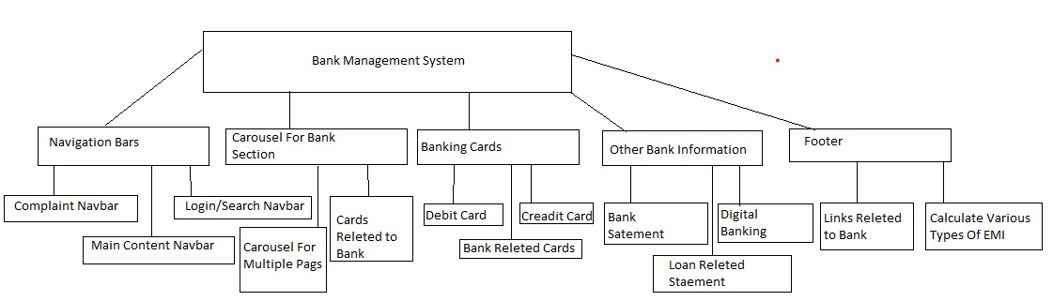

**System Requirement**

Software requirement:

1. Operating system: Windows XP/7 Higher
2. Programming Language: HTML,CSS,Javascript,Bootstrap,React js
3. Tools: Vs code

Hardware Requirement:

1. Ram: 8GB
2. SSD: 512GB

**Implementation**

Program

import React, { useState } from 'react';

import './BankNavbar.css'; // Include additional styles if needed

import bank1 from './bank1.jpg';

import bank2 from './bank2.jpg';

import bank3 from './bank3.jpg';

function CarouselBank() {

const [showForm, setShowForm] = useState(false);

const [formSubmitted, setFormSubmitted] = useState(false);

// Handle showing the form

const handleApplyNowClick = () => {

setShowForm(true);

setFormSubmitted(false); // Reset submission state

};

// Handle form cancellation

const handleFormCancel = () => {

setShowForm(false);

setFormSubmitted(false); // Reset submission state

};

// Handle form submission

const handleFormSubmit = (event) => {

event.preventDefault();

setFormSubmitted(true); // Set submission state

setTimeout(() => {

setShowForm(false); // Automatically close form after 2 seconds

}, 2000);

};

return (

<div>

{showForm ? (

<div className="container mt-5">

{formSubmitted ? (

<div className="alert alert-success" role="alert">

Form submitted successfully!

</div>

) : (

<>

<h2>Apply Now</h2>

<form onSubmit={handleFormSubmit}>

<div className="mb-3">

<label htmlFor="fullName" className="form-label">Full Name</label>

<input type="text" className="form-control" id="fullName" placeholder="Enter your full name" required />

</div>

<div className="mb-3">

<label htmlFor="email" className="form-label">Email address</label>

<input type="email" className="form-control" id="email" placeholder="Enter your email" required />

</div>

<div className="mb-3">

<label htmlFor="phone" className="form-label">Phone Number</label>

<input type="tel" className="form-control" id="phone" placeholder="Enter your phone number" required />

</div>

<div className="mb-3">

<label htmlFor="loanAmount" className="form-label">Loan Amount</label>

<input type="number" className="form-control" id="loanAmount" placeholder="Enter desired loan amount" required />

</div>

<button type="submit" className="btn btn-primary">Submit</button>

<button type="button" className="btn btn-secondary ms-2" onClick={handleFormCancel}>

Cancel

</button>

</form>

</>

)}

</div>

**Output**

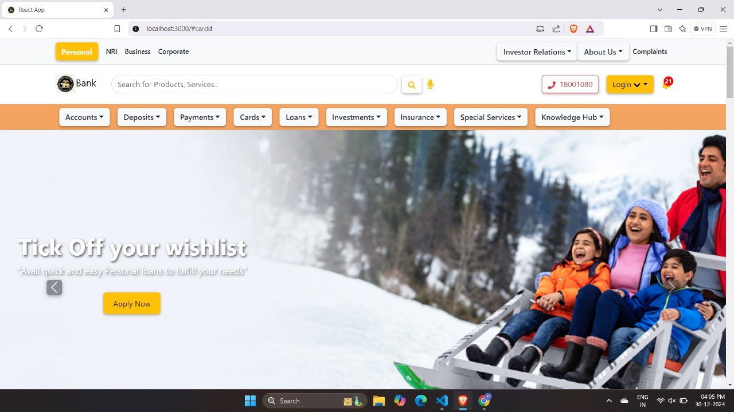

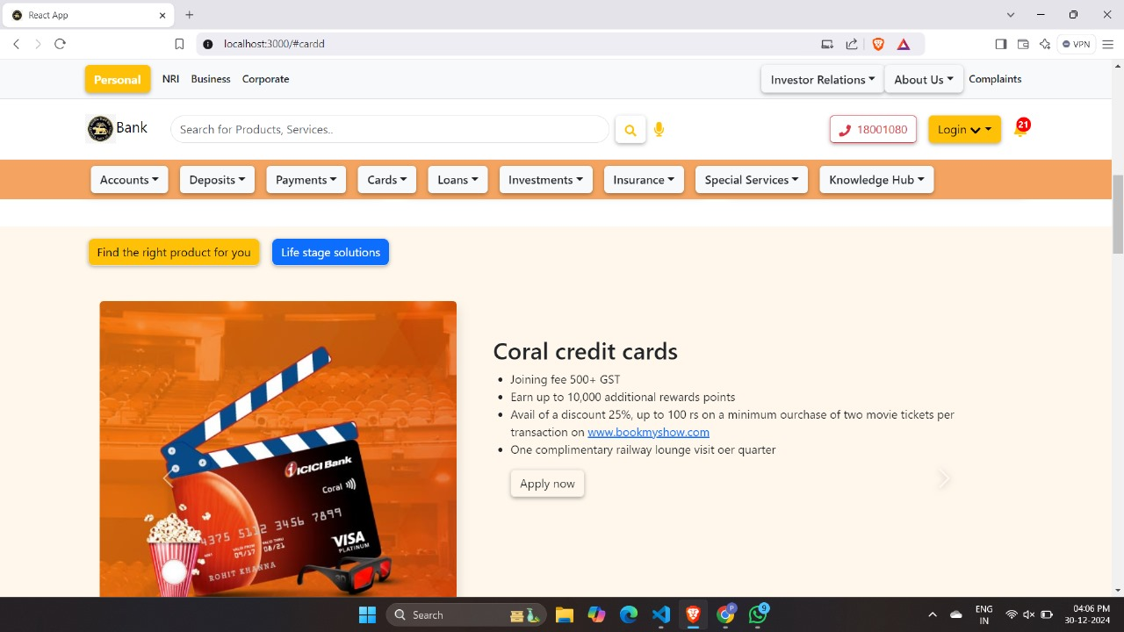

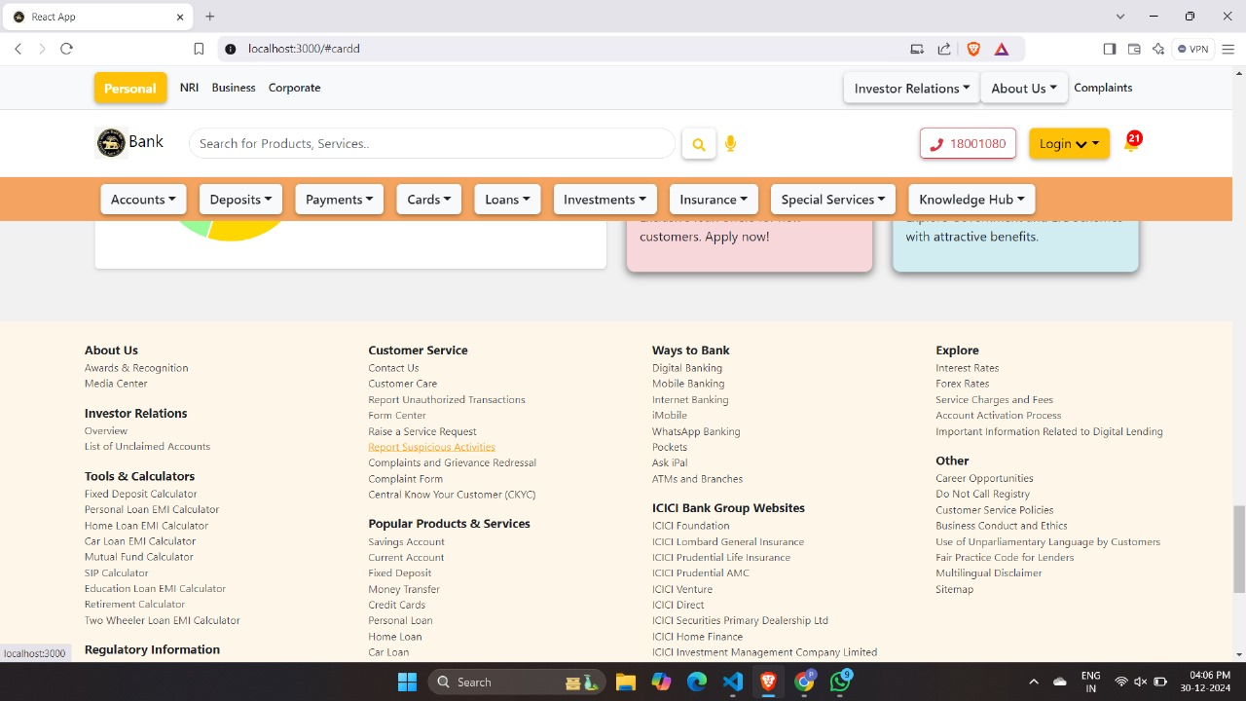

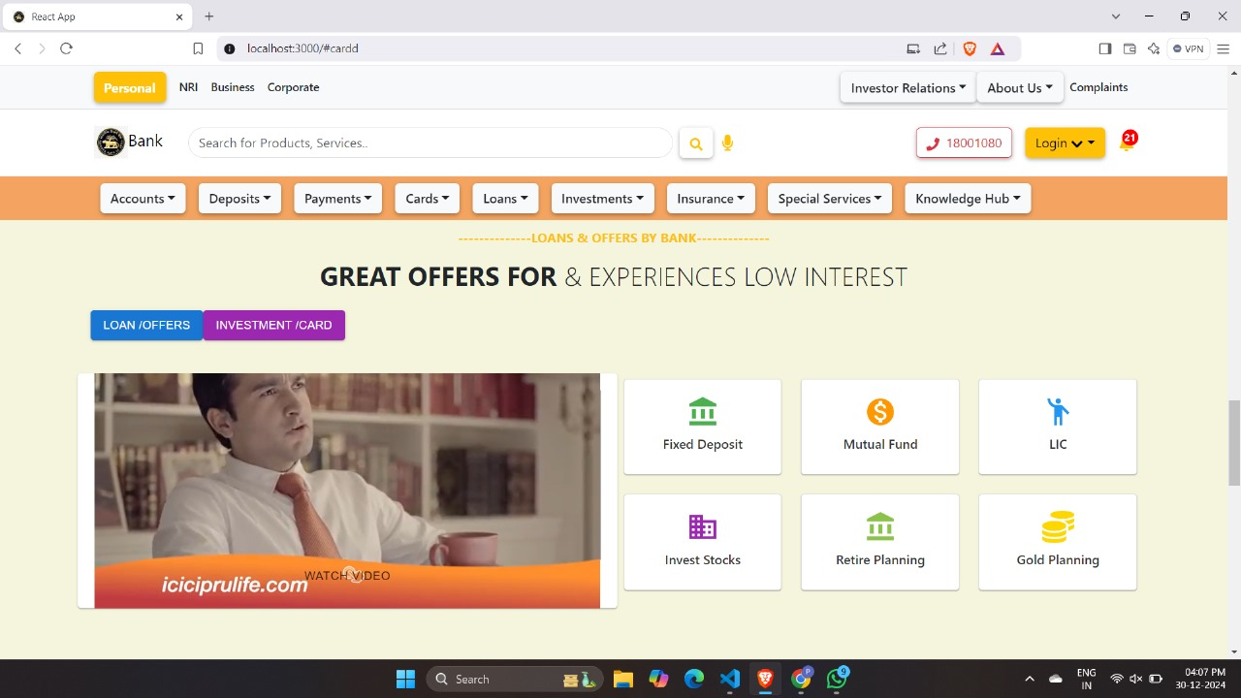

**Conclusion**

The Bank Management System project showcases the effective use of modern web development technologies to create a responsive, visually appealing, and user-friendly platform for banking operations. By leveraging React.js, along with HTML, CSS, JavaScript, and Bootstrap, the project demonstrates the potential of a component-based architecture to deliver dynamic and efficient solutions. The intuitive design and responsive layout ensure accessibility across a range of devices, enhancing the overall user experience.

**Reference**

[**https://getbootstrap.com/**](https://getbootstrap.com/)

[**https://www.youtube.com/**](https://www.youtube.com/)

[**https://react.dev/**](https://react.dev/)

[**https://www.icicibank.com/**](https://www.icicibank.com/)

[**https://www.rbi.org.in/**](https://www.rbi.org.in/)